# CORE 1. 黑龙江省 2010-2019 年火点活动特征总结

**一、时间维度：双峰值季节性 + 集中高峰周，异常值与农业活动强绑定**

1. 季节性特征：双峰值分布，严格匹配农业周期

火点季节曲线呈现 “春末夏初（3-4 月）+ 秋收后（9-10 月）双峰值”，两时段火点占全年总量的 70% 以上，冷季（11 月 - 次年 2 月）火点占比不足 20%。

1. 第一峰值（春末夏初）：对应周 12-15（3 月中下旬 - 4 月中下旬），为春耕前秸秆清理焚烧集中期，2017 年周 14 火点数达 6223 个（文档 3）；
2. 第二峰值（秋收后）：对应周 41-45（9 月下旬 - 10 月下旬），为玉米、大豆主粮收割后秸秆焚烧期，2015 年周 45 火点数达 6593 个（文档 3）；

对应文件：图片 5（2010-2019 年黑龙江省火点数量季节曲线.png）、图片 4（2010-2019 年黑龙江省火点平均 FRP 季节曲线.png）。

2. 周 / 旬尺度统计：高峰周集中，下旬火点更密集

1. 周统计：核心高峰周为周 12-15（春末夏初）和周 41-45（秋收后），十年间这 8 个周的火点总量占全年的 55% 以上（文档 1、3）；
2. 旬统计：多数年份下旬火点数量高于上、中旬，如 2015 年下旬火点数 13285 个，显著高于上旬 12156 个、中旬 7204 个（文档 2）；

对应文件：文档 1（2010-2019 黑龙江省火点高峰周统计表.csv）、文档 2（2010-2019 黑龙江省每旬火点统计表.csv）、文档 3（2010-2019 黑龙江省每周火点统计表.csv）。

3. 年度季节曲线对比：形态一致，年际差异显著

1. 所有年份均保持 “双峰值” 曲线形态，无例外，反映农业活动驱动的季节性是稳定规律（图片 4、5）；
2. 年际差异：2015 年、2017 年为火点高发年（全年火点数均超 3 万），2018 年为低谷年（全年火点数不足 1.5 万），峰值周火点数差异达 5-8 倍（文档 3）；

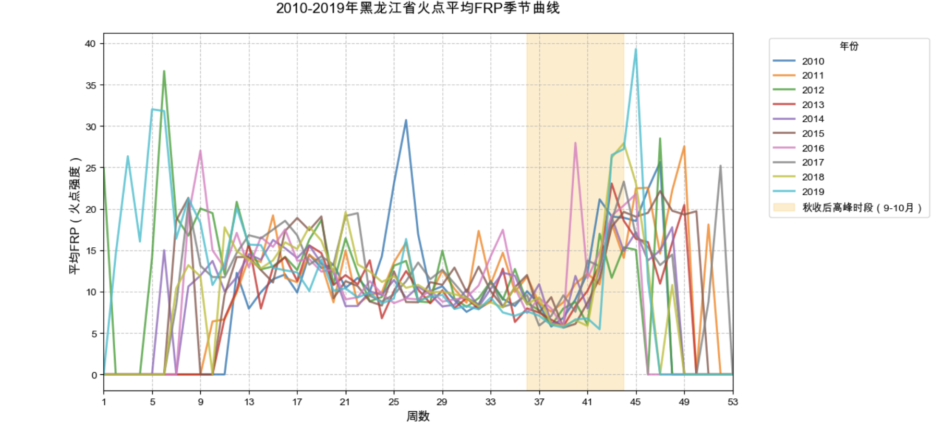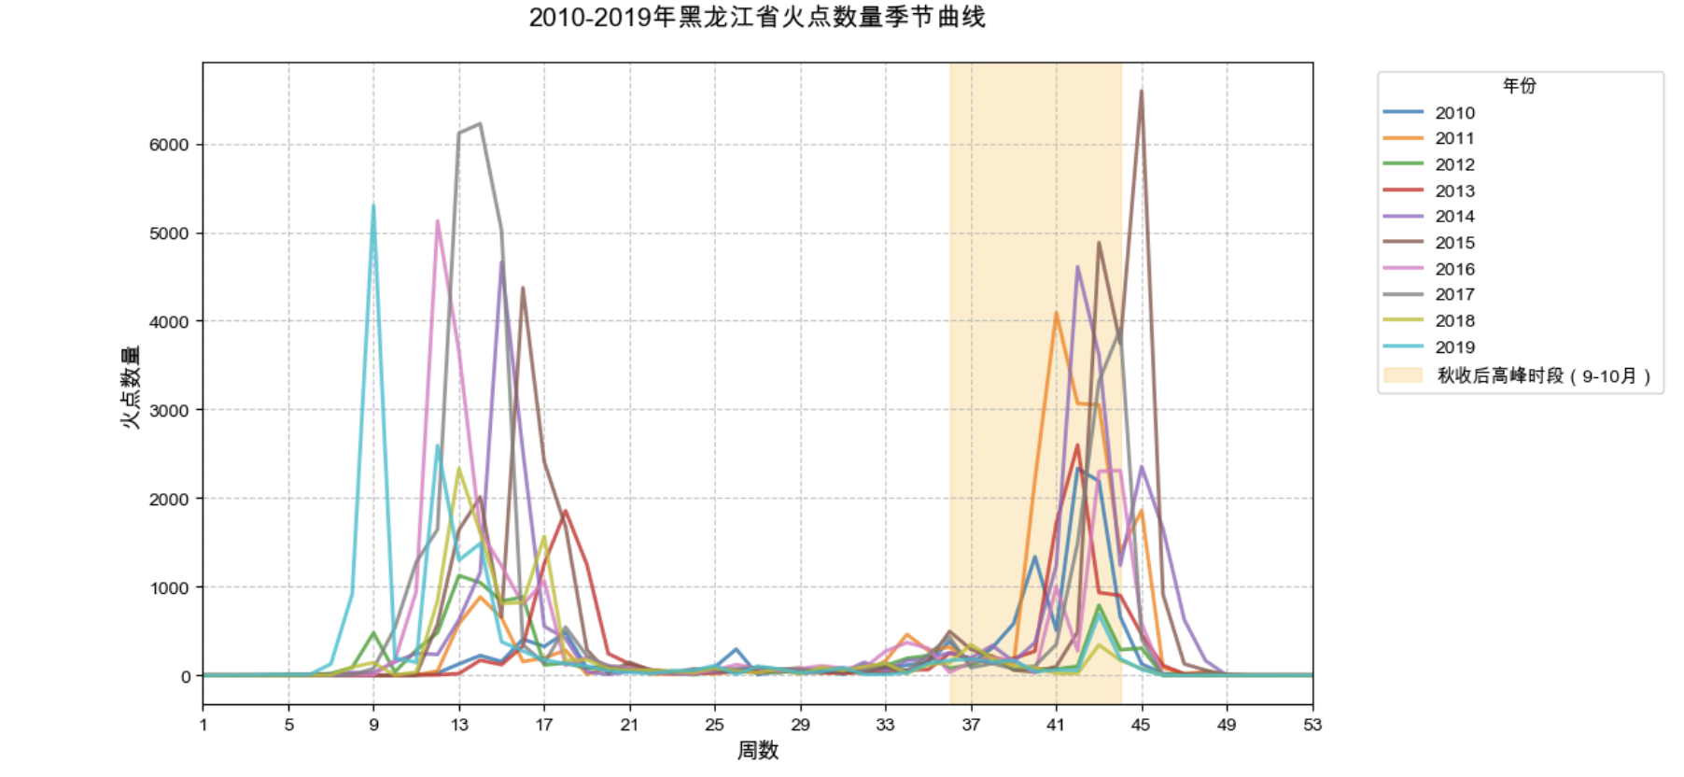

4. 异常高峰周识别：Z-score 标准化锁定农业相关异常

1. 十年共识别 20 个异常高峰周（is\_abnormal=True），均集中在两大农业周期：春末夏初（如 2017 年周 13-15）、秋收后（如 2015 年周 43-45）（文档 6）；
2. 异常原因：多与秸秆集中焚烧相关，部分异常周（如 2015 年周 45）需结合气象数据进一步分析干旱叠加影响（文档 6）；

**二、空间维度：两大农业平原带聚集，县级密度差异显著**

1. 核心聚集区域：两带聚集，冷点连片

基于 KDE 核密度分析（热点图），火点空间分布呈现 “松嫩平原西部 + 三江平原东部” 双热点带格局：

1. 核心热点带 1：松嫩平原西部（齐齐哈尔 - 大庆 - 绥化沿线），为火点最密集区域
2. 核心热点带 2：三江平原东部（佳木斯 - 双鸭山 - 鸡西沿线），为主粮种植核心区
3. 冷点区域：北部大兴安岭林区、南部牡丹江南部山区、哈尔滨城市核心区，火点极少；

对应文件：图片 7（2010-2019 年黑龙江省火点多年平均热点图.png）、图片 8（黑龙江省县级年均火点密度图.png）。

2. 县级密度特征：高密度县集中，分级差异明显

1. 密度分级：县级年均火点密度分为 5 级（0.00-0.02、0.02-0.04、0.04-0.06、0.06-0.09、0.09-1.24 个 / 平方公里），高密度县（0.09-1.24）集中在双热点带；
2. 核心高密度县：齐齐哈尔核心区（Qiqihaer\_Core）、富裕县（Fuyu4）等，火点密度显著高于其他区域；

3. 空间分析方法落地：KDE 热点图 + 县级叠加

火点转 GeoDataFrame 后，通过 KDE 分析生成空间热度图，直观呈现聚集特征（图片 7）；

与县界叠加后，精准计算县域火点密度，实现县级尺度差异识别（图片 8）；

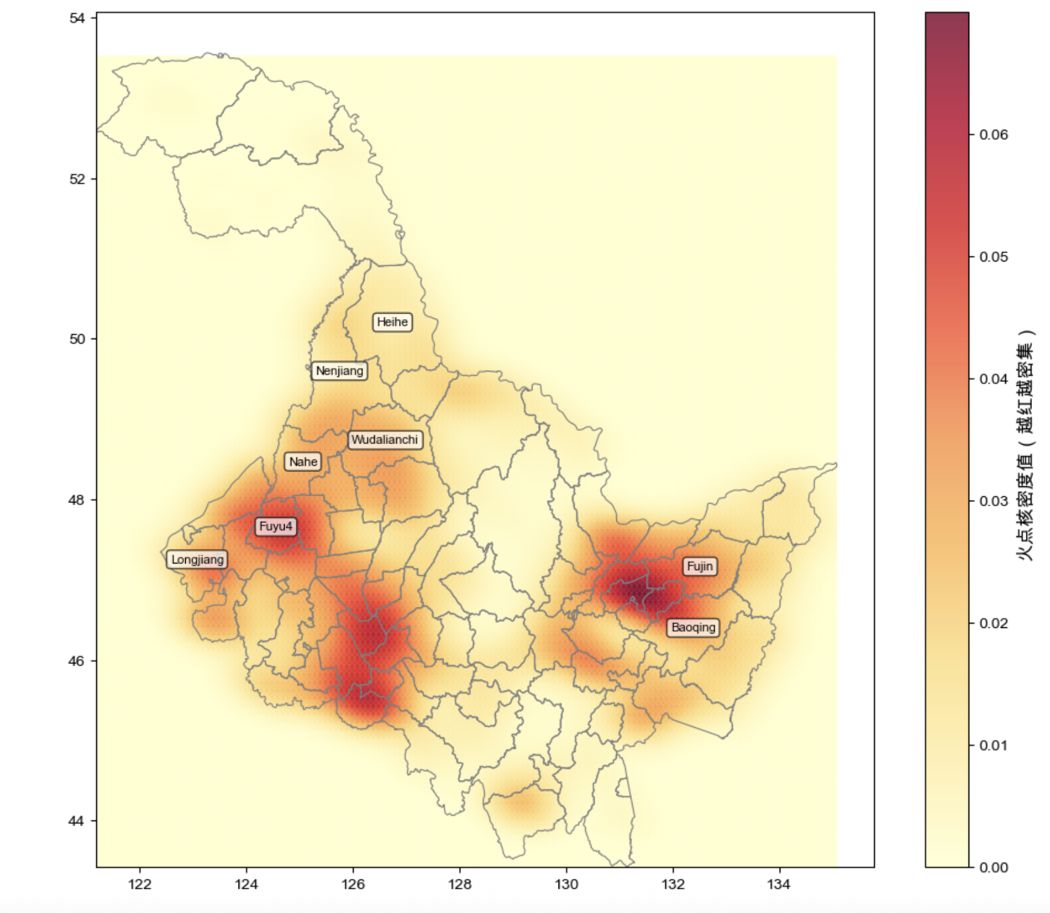

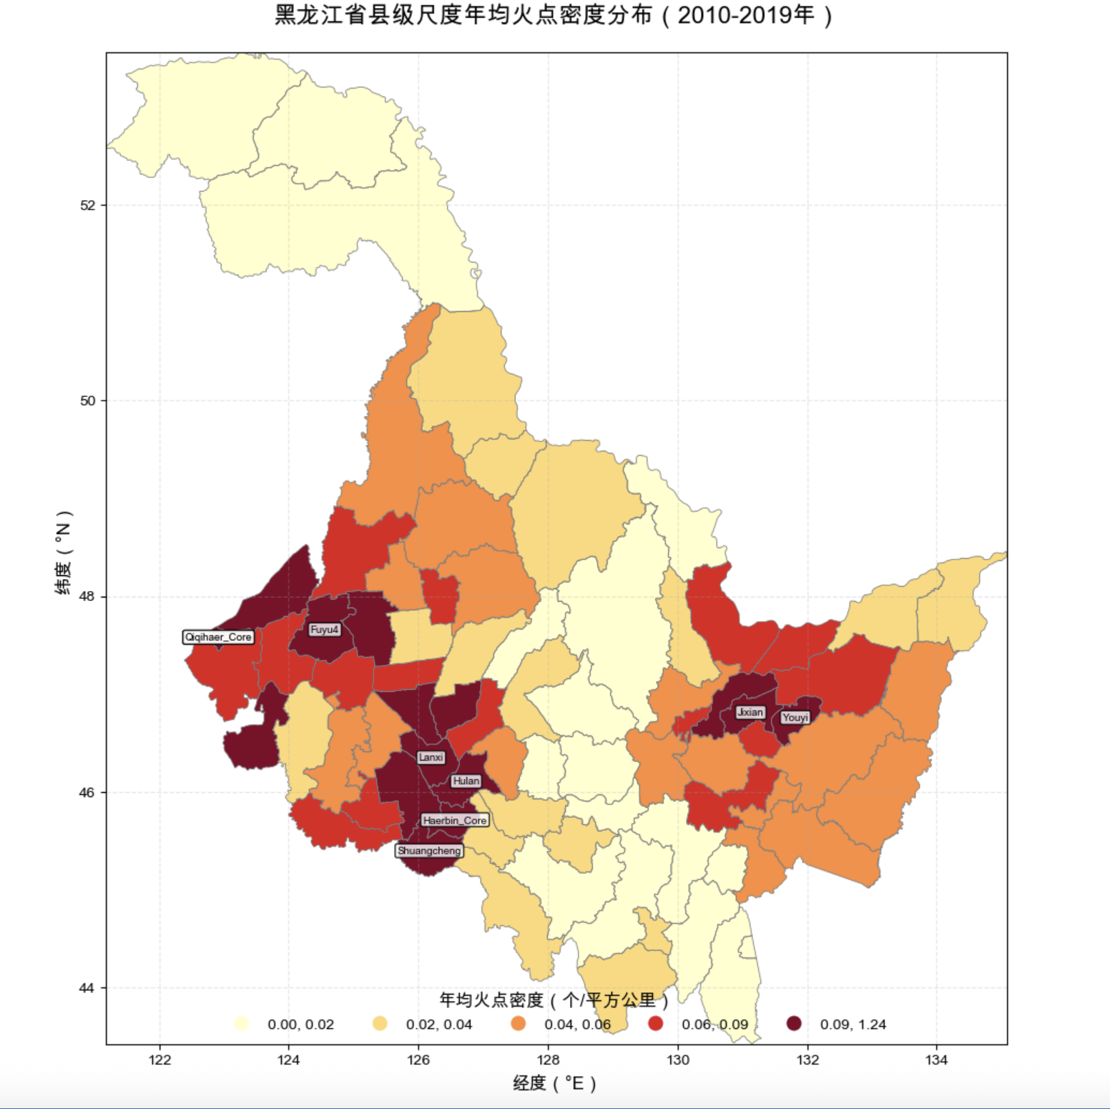

**三、每周火点数与平均 FRP 随时间变化：数量与强度同步关联**

1. 时间关联特征：高峰周同步，强度随数量升高

1. 火点平均 FRP（火灾辐射功率）与每周火点数呈显著正相关，高峰周同时也是高强度火灾集中期：2017 年周 14（火点数 6223 个，FRP16.43）、2015 年周 45（火点数 6593 个，FRP19.04）（文档 1、3）；
2. 冷季特征：11 月 - 次年 2 月不仅火点数量少，平均 FRP 也普遍低于 10，火灾强度弱（图片 4）；

对应文件：文档 1、文档 3、图片 4、图片 5。



2. 核心支撑图表：年均密度与多年热点图

1. 年均火点密度分布图：量化县域尺度强度差异，高密度县与高 FRP 区域高度重合（图片 8）；
2. 多年平均火点热点图：可视化空间强度聚集，热点带 FRP 均值（15-20）显著高于冷点区域（5-8）（图片 7）；

对应文件：图片 7、图片 8。





2010-2019 黑龙江省火点高峰周统计表.csv（文档 id1）

2010-2019 黑龙江省每旬火点统计表.csv（文档 id2）

2010-2019 黑龙江省每周火点统计表.csv（文档 id3）

2010-2019 黑龙江省火灾异常高峰周统计表.csv（文档 id4）

2010-2019 年黑龙江省火点平均 FRP 季节曲线.png（文档 id5）

2010-2019 年黑龙江省火点数量季节曲线.png（文档 id6）

2010-2019 年黑龙江省火点多年平均热点图.png（文档 id7）

黑龙江省县级年均火点密度图.png（文档 id8）

# 2. Cropland distribution and phenological data:

*Step 1：Data import and coordinate system unification*

加载火点数据、县界数据及多年的玉米和小麦物候期光栅，确保 CRS 保持一致（避免空间误差）

Load the fire point data, county boundary data, and multi-year raster data of the phenological periods of corn and wheat, and ensure that the CRS remains consistent (to avoid spatial errors).

*Step 2：Extract the year when the ignition point occurred and the DOY*

从火点的时间戳中解析  
→ 年份 year  
→ 一年中序列日期 doy

Parse from the timestamp of the fire point → year→ serial date doy within a year

*Step 3：Sample the phenological period of the corresponding year based on the coordinates of the fire point.*

针对每一年单独匹配对应物候影像  
• 若该位置落在玉米田：返回 maize\_doy  
• 若落在小麦田：返回 wheat\_doy  
• 否则标记为空

使用 rasterio.sample() 提高计算效率

For each fire hotspot location, the corresponding crop phenology maturity raster (DOY) must be matched for that specific year. The processing logic is as follows:  
• If the pixel falls within a maize cultivated area, return its maize maturity DOY (maize\_doy)  
• If the pixel falls within a wheat cultivated area, return its wheat maturity DOY (wheat\_doy)  
• If the location is not within either crop area, assign a missing value (NoData)

*Step 4：Determination of fire point type*

根据作物成熟前后 ±30天窗口期 判断是否与农忙焚烧相关：

满足条件 → 农业火点（maize / wheat）

否则 → 非农业火点（non-crop）

According to plus or minus 30 days before and after the crops mature window determine whether associated with busy farming burning:

meet the conditions to the fire (maize/wheat) or agriculture, non-agricultural point (non - crop)

*Step 5：Superimposed with administrative regions*

进行空间连接（Spatial Join），统计县域农业火点数量  
→ 生成分县热力分布图（玉米/小麦）

Conduct Spatial Join to count the number of agricultural fire points in the county → Heat distribution map of biomass in the county (corn/wheat)

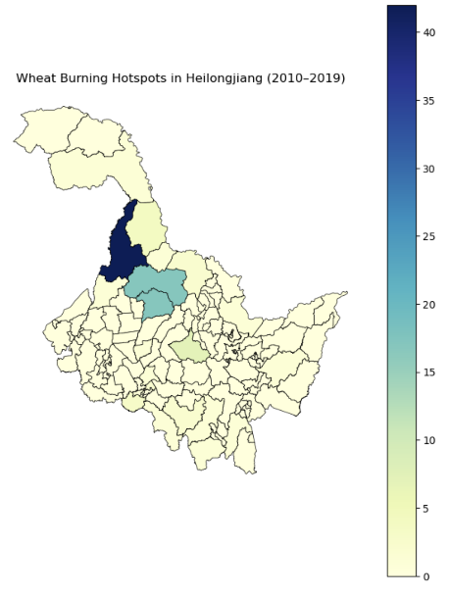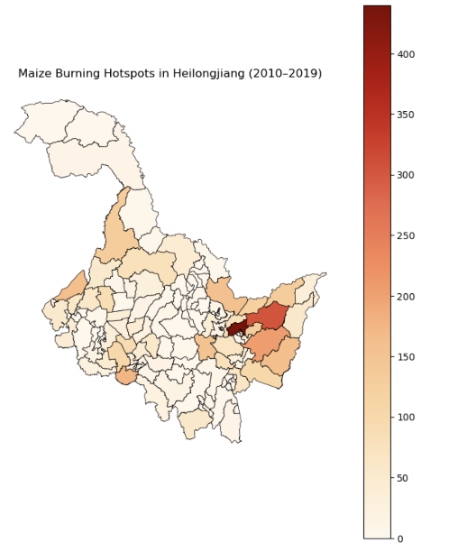

从地图中可以观察到，玉米与小麦秸秆焚烧火点在黑龙江省不同区域呈现出明显的空间差异。玉米焚烧热点主要集中于西部及中南部农业集中带，与玉米主要种植区高度一致；而小麦焚烧火点数量整体较少，且分布相对零散。这说明黑龙江的农业焚烧问题主要来源于玉米秸秆处理。此外，空间聚集性现象明显，反映农业生产布局与秸秆焚烧位置具有强相关关系。

这些空间分布结果回答了题目中关于“农业焚烧火点主要来源作物及其地理集中区域”的问题，证明了农业火点与作物种植区域存在显著空间关联，为后续制定区域化差异化管控提供依据。

The maps reveal clear spatial disparities in the distribution of maize and wheat straw-burning hotspots across Heilongjiang Province. Maize burning events are heavily clustered in the western and south-central agricultural regions, aligning closely with major maize production areas. In contrast, wheat burning occurrences are much fewer and more dispersed. This indicates that maize straw management is the primary contributor to agricultural fire activities in Heilongjiang. The spatial clustering suggests a strong correlation between agricultural planting patterns and the occurrence of fire hotspots. The spatial results directly address the research question regarding which crops contribute most to agricultural burning and where such activities are geographically concentrated. The findings confirm a strong spatial linkage between agricultural fires and crop cultivation zones, providing valuable evidence for region-specific management and regulation strategies.

*Step 6：Calculate the proportion*

农业火点占比=农业相关火点数量/全部火点数量​×100%

The proportion of agricultural fire points = the number of agricultural-related fire points/the total number of fire points ×100%

**3.FY (Fengyun) satellite-based straw burning fire point monitoring data:**

*Step 1: Import Libraries and Data*

使用 pandas 和 geopandas 读取 Excel 火点数据和 shapefile 边界数据。

Using pandas and geopandas to read the Excel fire point data and shapefile boundary data. Inspect columns and preview data.

*Step 2: Data Cleaning*

删除缺失经纬度的火点记录。根据经纬度生成 Point 对象，创建 GeoDataFrame，坐标系设为 WGS84（EPSG:4326）。

Drop rows with missing coordinates, create Point geometries, and set CRS to EPSG:4326.

*Step 3: CRS Transformation*

将县级边界数据的坐标系统一为 EPSG:4326，保证与火点数据一致。  
Transform county shapefile CRS to EPSG:4326 to match fire point CRS.

*Step 4: Spatial Join*

使用 gpd.sjoin 将每个火点匹配到所属县区。

仅保留黑龙江省的火点和县区数据。  
Perform spatial join to associate each fire point with its county and filter for Heilongjiang Province.

*Step 5: Process Dates*

将“时间”列转换为 datetime 类型，提取月份和年份。

用 groupby 统计各月和各县的火点数量。

Convert date column to datetime, extract month and year, and group by month and county to count fire points.

*Step 6: Visualize Spatial Distribution*

绘制黑龙江省地图轮廓。

将火点叠加在地图上，红色点表示火点位置。

Plot Heilongjiang county boundaries and overlay fire points as red dots.

总结：结果显示，农业秸秆焚烧仅占全部监测火点的 **2.23%**。这意味着黑龙江省大多数火点与农作物收获期无直接关系，可能来源于荒地、林草区或其他非法焚烧行为。该发现有助于政府更加精准地制定禁烧策略，将监管重点聚焦于农业集中区域。

The proportion of agricultural burning accounts for only **2.23%** of all detected fires in Heilongjiang. This indicates that most fires are unrelated to crop harvest activities, potentially originating from grassland or non-agricultural areas. The findings provide useful evidence for strengthening targeted policies on straw burning management.

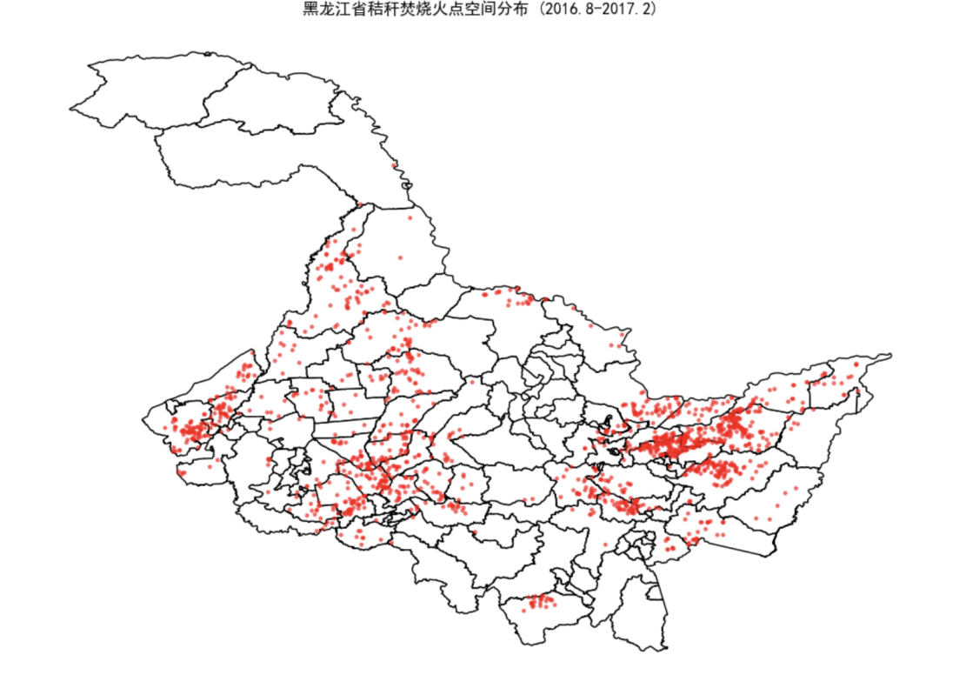

从这个图中可以得到：

这张图显示了黑龙江省秸秆焚烧火点的空间分布情况，红色点主要集中在农业区，尤其是玉米和大豆种植较多的县，而城市和山区火点较少，表明燃烧行为主要与农业生产活动相关。不同县的火点密度差异明显，为后续统计分析、火点监测和政策干预提供依据。同时结合月度趋势分析，可推测存在明显的季节性燃烧规律，为高密度区域的重点监管和秸秆综合利用提供参考。

This map shows the spatial distribution of straw burning fire points in Heilongjiang Province. The red points are mainly concentrated in agricultural areas, especially counties with large corn and soybean cultivation, while urban and mountainous areas have fewer fires, indicating that the burning is primarily related to agricultural activities. There are clear differences in fire density between counties, providing a basis for further statistical analysis, monitoring, and policy interventions. Combined with monthly trend analysis, it suggests a distinct seasonal burning pattern, which can guide targeted supervision and straw utilization strategies in high-density areas.

*Step 7: Plot Monthly Trend*

将 month 转换为字符串，绘制折线图显示火点数量随时间变化。

Plot line chart of monthly fire counts from August 2016 to February 2017.

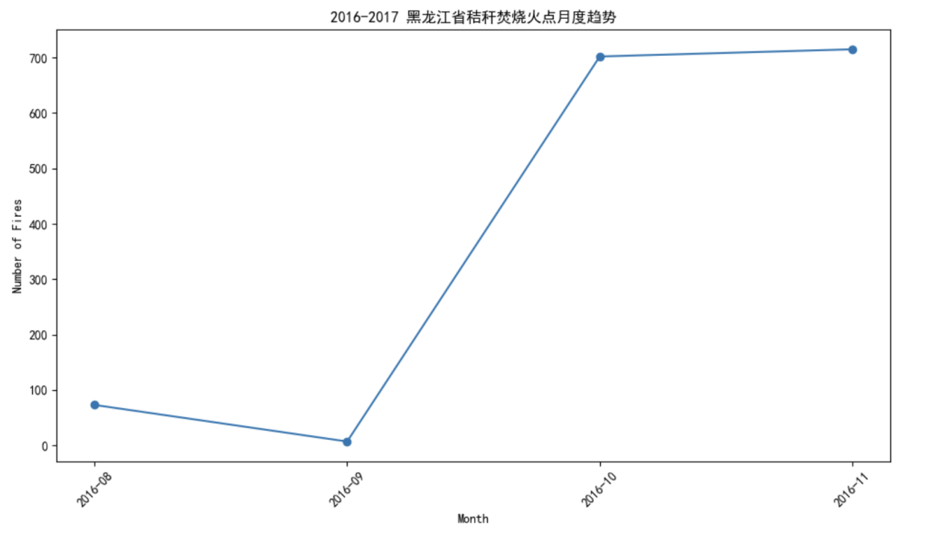

从这个图中可以得到：

该折线图展示了2016年8月至2017年2月期间黑龙江省秸秆焚烧火点的时间变化趋势。可以清晰看出火点数量在秋收后迅速上升，并于10月至11月达到高峰，随后随着入冬和管控加强火点数量明显下降。该图回答了题目中关于秸秆焚烧的季节性特征与时间分布规律的问题，说明秸秆焚烧主要集中在秋冬交替的农闲时段。

This line chart shows the monthly trend of straw burning fire points in Heilongjiang Province from August 2016 to February 2017. The number of fire points increases rapidly after the autumn harvest and peaks around October to November, followed by a significant decline in winter due to stricter controls and weather conditions. This figure addresses the research question concerning the temporal distribution and seasonal characteristics of straw burning, indicating that the activity is largely concentrated during the post-harvest period in autumn and early winter.

总结：从结果来看，黑龙江省秸秆焚烧事件在空间上呈现显著的农业区域集中特征，主要分布于粮食主产区，尤其是玉米种植带，其火点数量显著高于小麦区。在时间维度上，焚烧行为明显集中于秋季收获后阶段，体现出典型的农业季节性特征。这表明秸秆处理方式仍与作物种植结构紧密相关，农业废弃物管理压力在主要粮食产区更为突出。该分析不仅揭示了焚烧火点的主要来源和聚集趋势，也为区域差异化的监管策略和秸秆资源化利用政策提供了依据。

The results show a clear spatial clustering of straw-burning activities in Heilongjiang, concentrated mainly within major agricultural production zones, especially maize-growing areas where fire occurrences are significantly higher than in wheat regions. Temporally, the burning events peak during the post-harvest autumn period, reflecting strong seasonality tied to agricultural practices. These findings indicate that crop residue management remains closely associated with planting patterns, with greater pressure in core grain-producing areas. This analysis not only identifies the primary sources and geographical hotspots of agricultural burning but also provides evidence to support targeted regional regulation and the promotion of resource-efficient straw utilization strategies.

# 3:Analysis of Fire Characteristic Differences

**Fire Intensity (FRP):**

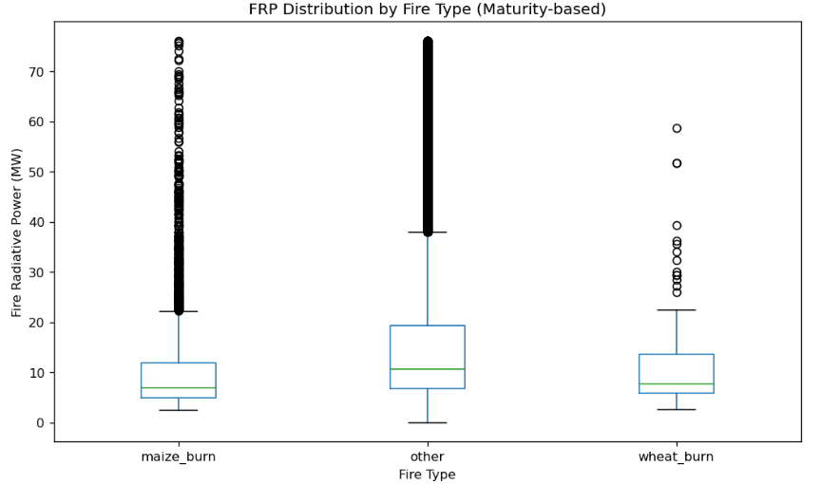

- Mean FRP (Agricultural Fires): 10.52 MW

- Mean FRP (Other Fires): 15.65 MW

- Significance Test Result: Significant difference (p < 0.05)

从图中可以看出，不同类型火点的火辐射功率（FRP）分布存在明显差异。

**农业火点（maize\_burn、wheat\_burn）** 的 FRP 整体较低，中位数集中在 5–10 MW 之间，且分布较窄，说明农业焚烧主要是**小规模、低强度的秸秆燃烧活动**。

**非农业火点（other）** 的 FRP 显著更高，不仅中位数和上四分位数更大，还出现大量**高强度离群点（>70 MW）**，说明其包含了**森林火灾、草原火灾等高能量燃烧事件**。

由此可见，农业火灾数量较多但燃烧强度低，而非农业火灾数量较少但能量输出高，是**主要的高能量辐射来源**。

总结：

农业火灾以低能量、季节性燃烧为特征；  
非农业火灾则主导了强烈燃烧事件，对碳排放与空气污染影响更大。

The boxplot clearly shows significant differences in Fire Radiative Power (FRP) across fire types.

**Agricultural fires (maize\_burn, wheat\_burn)** exhibit lower and more concentrated FRP values, with medians around 5–10 MW, indicating **small-scale, low-intensity residue burning**.

**Other fires** display higher FRP levels, with larger interquartile ranges and numerous **high-intensity outliers (>70 MW)**, reflecting **wildfires and grassland fires** with stronger combustion energy.

Overall, agricultural fires are **numerous but low-energy**, while non-agricultural fires are **fewer but more intense**, contributing the **major share of total radiative energy**.

Conclusion：

Agricultural burning represents **low-intensity, seasonal human activities**,  
whereas non-agricultural fires dominate **high-energy combustion and emission impacts**.

**Temporal Distribution:**

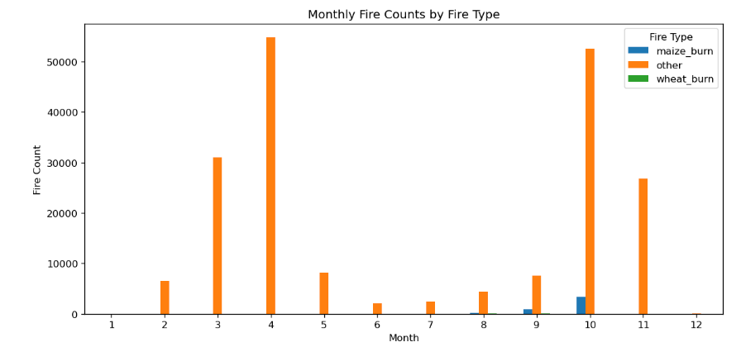

**火灾具有明显的季节性分布特征**。

其他火点（other）” 在 **3月与4月** 出现两个显著高峰，其中4月数量最多，超过5万起。

表明春季是黑龙江地区**森林与草原火灾高发期**，主要受气候干燥与人类活动（如开荒、烧荒）影响。

**农业火点集中在秋季（9–11月）**

maize\_burn（玉米火点）” 与 “wheat\_burn（小麦火点）” 明显集中在 **9–11月**，尤其是10月。

对应于**秋收后的秸秆焚烧季节**，说明农业焚烧具有高度集中、短期爆发的特征。

**数量差异明显。**

农业火点数量远低于其他火点，但其时间分布更集中，说明它们是**人为、季节性燃烧行为**；

其他火点数量多、分布广、持续时间长，反映出**自然因素主导的火灾风险**。

结论：

黑龙江地区火灾具有显著的季节规律——  
春季（3–4月）以**非农业火灾**为主，秋季（9–11月）以**农业焚烧火点**为主。  
两者在时间上错峰出现，反映出不同的成因与控制机制

The chart clearly shows a **distinct seasonal pattern** in fire occurrence across fire types:

**Strong seasonality:**

**Other fires** peak sharply in **March and April**, with April showing the highest count (>50,000 fires).  
→ This indicates that **spring wildfires and grassland fires** dominate during the dry season, driven by climatic and human ignition factors.

**Agricultural burning in autumn:**

**Maize\_burn** and **wheat\_burn** fires cluster tightly between **September and November**, especially in October.  
→ This aligns with **post-harvest residue burning**, showing the seasonal nature of agricultural fires.

****Distinct scale difference:****

Agricultural fires are **fewer but highly concentrated**, reflecting **short-term, human-controlled burning**;

Other fires are **numerous and widespread**, representing **larger, more natural or accidental events**.

**Conclusion：**

Fires in Heilongjiang exhibit clear **bimodal seasonality** —  
spring dominated by **wildfires**, autumn by **agricultural burning**.  
This temporal separation highlights their **different origins and management implications**.

##### **Spatial Distribution[¶](http://localhost:8888/notebooks/Q3 and challenge 1.ipynb" \l "3%EF%B8%8F%E2%83%A3-Spatial-Distribution" \t "/Users/dinglee/Library/Containers/com.kingsoft.wpsoffice.mac/Data/tmp/wps-dinglee/x/_self)**

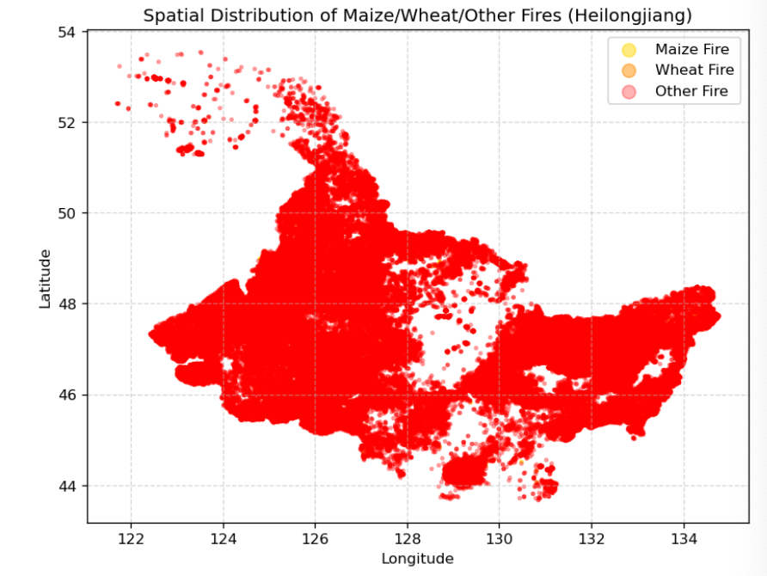

**火点在空间上分布极不均匀**。

绝大多数火点（红色表示“其他火点”）集中在黑龙江省的中部和东部地区，  
特别是在松嫩平原与三江平原交界地带，火点密集度最高。

**农业火点比例较低。**

图中几乎看不到明显的黄色（maize）和橙色（wheat）火点，  
说明农业焚烧火点相对于整体火点数量极少，占比不足 3%，  
符合数据结果（农业火点 4662 起，占总火点约 2.3%）。

**非农业火点（other）占主导地位**

红色火点广泛分布在全省范围，尤其是北部和东部森林地带，  
表明这些地区以**自然火灾（森林火、草原火）或非农燃烧源**为主。

**区域分布特征明显：**

西部（松嫩平原）与南部（农田区）零星火点 → 人为焚烧为主；

北部与东部（林地丘陵区）高密集分布 → 森林和草原火灾更集中。

结论：

黑龙江省火点空间分布具有显著的区域差异：  
农业火灾主要出现在平原农业区，数量少而集中；  
非农业火灾则广泛分布在森林与草原地区，是火灾活动的主要类型与能量来源。

**Highly uneven spatial pattern:**

Most fire points (red dots for “other fires”) are concentrated in the **central and eastern plains**,  
particularly in the **Songnen and Sanjiang Plain** regions.

**Agricultural fires are relatively rare:**

Very few yellow (maize) or orange (wheat) dots are visible,  
indicating that **agricultural burning events make up only a small fraction (<3%)** of all fires,  
consistent with the data (≈2.3% of total fire points).

**Non-agricultural fires dominate:**

Red fire points cover almost the entire province, especially **northern and eastern forested areas**,  
suggesting that **wildfires and grassland fires** are the main contributors to total fire activity and intensity.

**Regional differentiation:**

Western and southern plains: sparse fires, mostly **anthropogenic residue burning**;

Northern and eastern highlands: dense clusters, mainly **forest and grassland wildfires**.

Conclusion：

Fires in Heilongjiang show **clear spatial heterogeneity** —  
agricultural fires are localized and low-intensity,  
while non-agricultural fires are widespread, powerful, and dominate overall fire energy release.

Overall conclusion：

总体来看，农业火灾虽然发生频繁，但多为人为控制的低强度燃烧活动；相比之下，其他火灾数量较少，却具有更高的辐射功率和能量输出，反映出更大规模、更剧烈的燃烧过程

Agricultural fires are frequent but low in intensity, forming a distinct anthropogenic burning pattern, while other fires are fewer but stronger and more energy-intensive

# Challenge 1: Intensity & Impact Analysis

##### **FRP Statistics**

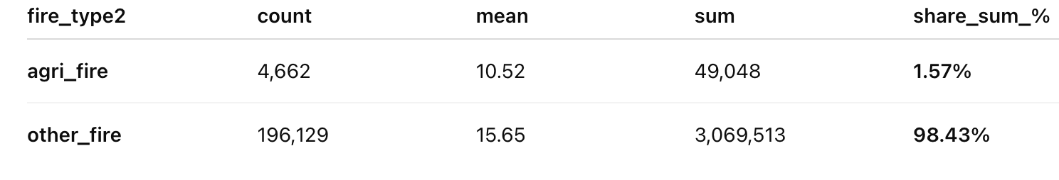

农业火灾虽然**数量较多（约4600个）**，  
但每个火点的平均FRP仅为 **10.52 MW**，说明多为**小规模、低强度燃烧**；其总能量贡献仅占全体火灾的 **1.57%**。

非农业火灾虽然**数量更多（约19.6万个）**，  
但其平均FRP高达 **15.65 MW**，  
累计能量占比高达 **98.43%**，说明**大部分能量释放来自非农业火灾**（例如森林或草原火灾）。

结论：

农业火灾“数量多但能量低”，  
非农业火灾“数量多且能量贡献绝对主导”，  
两类火灾在强度与环境影响上的差异非常明显。

Agricultural fires have **many occurrences (≈4,662 points)**  
but low average FRP (**10.52 MW**), meaning they are **small-scale and low-intensity**.Their total radiative contribution is only **1.57%** of all fires.

Other fires (**≈196,000 points**) exhibit a higher mean FRP (**15.65 MW**)  
and dominate the total radiative energy, contributing **98.43%**.

Conclusion：

Agricultural fires are numerous but weak,  
while non-agricultural fires release almost all of the total radiative energy,  
indicating their dominant role in strong combustion and atmospheric impacts.

**FRP Cumulative Distribution Function (ECDF)**

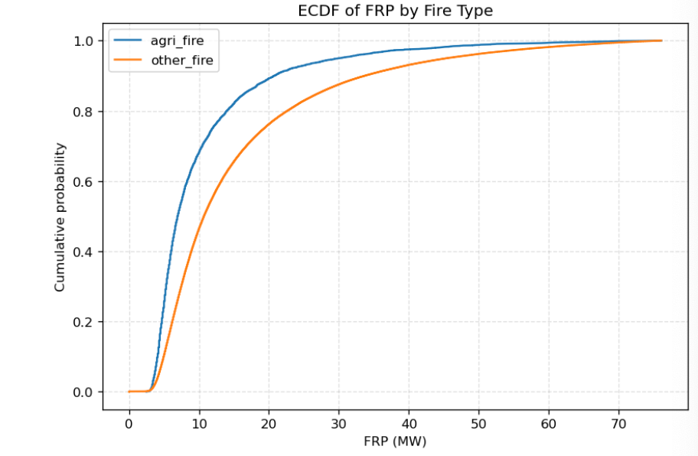

蓝线在低 FRP 区间（例如 10–15 MW）上升更快，这意味着：大部分农业火灾的 FRP 值较低；约 90% 的农业火点 FRP 小于 15 MW。农业火灾强度低、能量小，集中在低FRP区间

橙线（非农业火灾）上升更慢，在高 FRP 区域（20 MW 以上）仍有显著分布，  
表明非农业火灾中存在更多高强度火点。其他火灾强度高、分布更广，能量更大

结论：

该图清晰地显示出农业火灾的 FRP 分布明显偏低，  
而非农业火灾具有更长的高强度尾部，说明其燃烧能量更强、环境影响更大。

The **blue curve (agri\_fire)** rises sharply within the low-FRP range (below ~15 MW),indicating that the vast majority of agricultural fires are **low-intensity** events.  
About 90% of agricultural fires have FRP values below 15 MW.**Agricultural fires:** Low energy, small-scale, and human-controlled burning (e.g., crop residue burning).

The **orange curve (other\_fire)** increases more gradually and extends further to the right,  
showing that **non-agricultural fires** include more **high-intensity** and **high-energy** burning events.**Other fires:** High energy, broader FRP range, and often associated with wildland or forest fires.

**Conclusion：**

The ECDF reveals that agricultural fires are concentrated in the **low-FRP range**,  
while other fires exhibit a **longer high-intensity tail**, highlighting their stronger combustion and greater potential environmental impact.

**Identification of “Intense Combustion Events”**

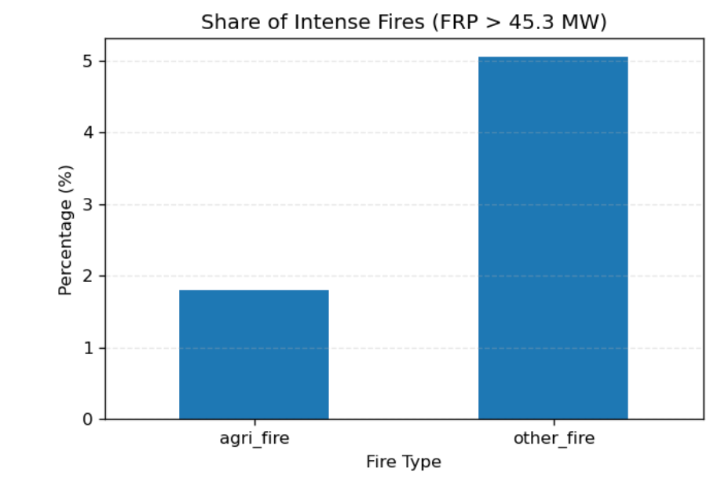

**阈值定义：** FRP > 45.3 MW 被视为“强烈燃烧事件”；这个阈值是整个样本 FRP 的第 95 个百分位。

蓝色柱状图表示各类火灾中强烈火点的占比。

**农业火灾（agri\_fire）：** 约 **1.8%** 的火点属于高强度燃烧；

**其他火灾（other\_fire）：** 高强度火点比例高达 **5.0%**。

**结论：**

这表明农业火灾多为小规模、低能量的焚烧活动（如秸秆焚烧），  
其环境影响主要来自**频繁性和面源污染**；  
而非农业火灾单次能量巨大

**Threshold definition:**  
FRP > 45.3 MW is considered an “intense burning event”;  
this threshold corresponds to the **95th percentile** of all FRP values in the sample.  
The blue bars represent the **proportion of intense fires** within each fire type.

**Agricultural fires (agri\_fire):** about **1.8%** of the fires fall into the high-intensity category.  
**Other fires (other\_fire):** the share of high-intensity fires reaches **5.0%**.

**Conclusion:**  
This indicates that **agricultural fires** are mostly **small-scale, low-energy burning activities** (such as crop residue burning).  
Their environmental impact mainly comes from their **frequency and widespread distribution**.  
In contrast, **non-agricultural fires** have **much higher energy per event**,  
posing greater potential for extreme emissions and regional pollution.

##### **Time-based verification: Monthly total volume + Monthly occurrence of significant events**

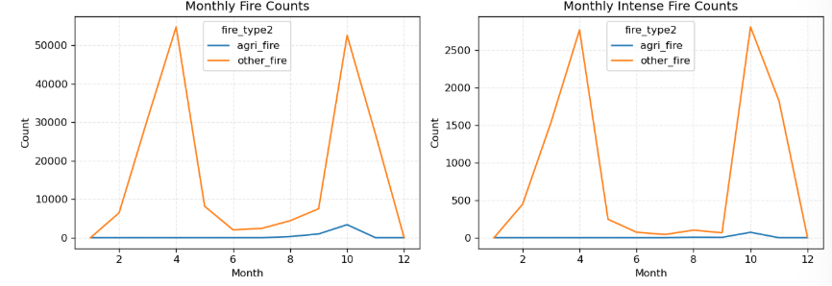

左图展示了不同类型火灾的**月度总发生次数**，右图展示了\*\*强烈火灾（FRP > 45.3 MW）\*\*的月度数量变化。

左图：

非农业火灾（orange）在 **4 月和 10 月** 出现明显的双峰，  
说明这些火灾主要集中在春季和秋季的**森林或草地易燃期**；

农业火灾（蓝线）数量总体较少，但在 **10 月至 11 月** 有轻微上升，对应黑龙江秋季收割后的**秸秆焚烧季**。

右图：

非农业火灾不仅数量多，而且在强烈燃烧事件中占主导，  
特别是 4 月和 10 月的高峰代表了典型的**春秋季森林火灾高风险期**；

农业火灾的高强度事件数量极少，说明其燃烧强度总体较低。

结论：

农业火灾主要集中在秋收季节（9–11 月），强度较低且具季节性；  
非农业火灾在春秋两季均频繁发生，尤其在春季出现大规模高强度燃烧，  
反映出自然条件（干旱、风大）和地表燃料差异对火灾行为的影响。

The left panel shows the **monthly total fire counts** for different fire types, while the right panel illustrates the **monthly variation in intense fires (FRP > 45.3 MW)**.

**Left panel:**  
Non-agricultural fires (orange) exhibit two distinct peaks in **April and October**, indicating that these fires mainly occur during the **flammable spring and autumn periods** in forest and grassland areas.  
Agricultural fires (blue) are fewer overall but show a slight increase between **October and November**, corresponding to the **post-harvest straw burning season** in Heilongjiang.

**Right panel:**  
Non-agricultural fires not only occur more frequently but also dominate the **intense burning events**, with pronounced peaks in **April and October**, representing the **typical high-risk wildfire seasons** in spring and autumn.  
Agricultural fires, in contrast, have very few high-intensity cases, suggesting that their overall burning intensity remains relatively low.

**Conclusion:**  
Agricultural fires are concentrated in the **autumn harvest season (September–November)**, showing **low intensity and clear seasonality**.  
Non-agricultural fires occur **frequently in both spring and autumn**, with particularly large and intense events in spring,  
reflecting how **natural conditions (e.g., dryness, strong winds)** and **surface fuel differences** influence fire behavior.

##### **Spatial Validation: Spatial Distribution of Strong Events**

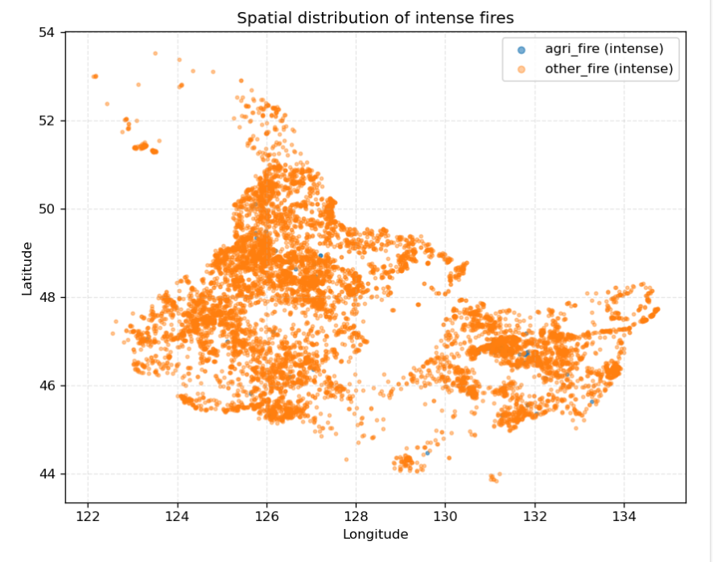

这张图展示了黑龙江省范围内\*\*强烈火灾（FRP > 45.3 MW）\*\*的空间分布情况：

可以看到，**非农业火灾（橙色）在空间上几乎覆盖整个省域，尤其集中在北部和东部的森林与草地地区**，这些区域地形起伏、植被丰富，容易发生高强度燃烧。

**农业火灾（蓝色）的点非常少且分布零散，主要位于中南部的农业平原地带，说明农业火灾极少达到强烈燃烧水平**。

这种分布格局表明，**强烈火灾的空间分布主要受自然地表类型和燃料条件影响**，而非农业火灾（如林火、草火）是黑龙江高强度燃烧的主要来源。

结论：

强烈燃烧事件主要集中在森林、草地等自然区域，呈现出明显的地理聚集性；  
农业火灾虽然普遍存在，但燃烧能量有限，难以形成高强度事件。

This figure shows the **spatial distribution of intense fires (FRP > 45.3 MW)** across Heilongjiang Province:  
Non-agricultural fires (orange) are distributed almost throughout the entire province, with particularly high concentrations in the **northern and eastern forest and grassland regions**, where undulating terrain and abundant vegetation make **high-intensity combustion** more likely.  
Agricultural fires (blue) are **very few and scattered**, mainly appearing in the **central and southern agricultural plains**, indicating that agricultural fires **rarely reach high-intensity levels**.

This spatial pattern suggests that the **distribution of intense fires is primarily influenced by natural land cover and fuel conditions**, and that **non-agricultural fires (such as forest and grassland fires)** are the **main source of high-intensity burning** in Heilongjiang.

**Conclusion:**  
Intense burning events are mainly concentrated in **natural areas such as forests and grasslands**, showing a clear spatial clustering pattern.  
Although agricultural fires are widespread, their **burning energy is limited**, making it difficult for them to develop into **high-intensity fire events**.

Overall conclusion：

基于MODIS火辐射功率（FRP）数据，本研究比较了黑龙江省农业火灾与非农业火灾的能量强度差异。结果显示两者存在显著区别。

农业火灾的平均FRP约为10.5 MW，显著低于非农业火灾的15.6 MW（p < 0.05），表明农业焚烧（主要为收割后秸秆燃烧）属于低能量、可控型燃烧，而非农业火灾（森林与草原火）规模更大、燃烧更强。

以FRP > 45.3 MW（样本95分位）为强烈火点标准，农业火灾仅有1.8%达到此强度，而非农业火灾高达5.0%，说明农业火灾极少演变为高强度事件。

从时间上看，农业火灾集中于9–11月的秋收焚烧季；非农业火灾在4月与10月形成双峰，对应春秋两季的森林草原火高发期。

在空间上，强烈火灾主要聚集于黑龙江北部与东部的林草地带，农业火灾则局限于南部农区，燃烧能量普遍较低。

结论：

农业火灾数量多但强度低且具季节性，属于人为管理下的秸秆燃烧；

非农业火灾则主导高能量燃烧事件，在极端火灾与能量释放中占主要地位。

Based on MODIS-derived Fire Radiative Power (FRP) data, this study compared the energy intensity of agricultural fires and non-agricultural fires in Heilongjiang Province.

The results show a clear and significant difference between the two fire types.

Agricultural fires have a mean FRP of about 10.5 MW, notably lower than 15.6 MW for non-agricultural fires (p < 0.05). This indicates that agricultural burning, mainly residue combustion after harvest, is low-energy and controlled, whereas non-agricultural fires—mostly forest and grassland fires—are larger-scale and more intense.

Using the 95th percentile (FRP > 45.3 MW) as the threshold for “intense fires,” only 1.8% of agricultural fires reached this level, compared with 5.0% of non-agricultural fires, confirming that agricultural burning rarely escalates into high-intensity events.

Temporally, agricultural fires peak in September–November, aligning with the post-harvest season, while non-agricultural fires show dual peaks in April and October, corresponding to typical spring and autumn wildfire periods.

Spatially, intense fires are clustered in forested and grassland regions in the north and east, whereas agricultural fires remain limited to southern farmlands and are generally weak in energy.

Conclusion:

Agricultural fires are frequent but low-intensity and seasonal, reflecting human-managed residue burning.

In contrast, non-agricultural fires produce most high-energy events, dominating extreme combustion and total radiative output.

# Challenge 2

When classifying fire points, we conduct comprehensive assessments based on their spatial and temporal attributes, validated using FY satellite data. Below, we analyze potential sources of error, their possible impacts, and optimization methods from the perspectives of data, spatial distribution, and temporal factors.

**I. Data Layer**

1. MODIS Data

(1) Limited Detection Accuracy of MODIS Data

The MODIS data we utilize has a spatial resolution of 1 km and a detection frequency of four times per day. Consequently, fire points with small burn areas and short burn durations are prone to being missed, leading to an underestimation of the proportion of agricultural burning.

(2) Misidentification of Strongly Reflective Surfaces

The MODIS algorithm may misclassify high-temperature surfaces (such as bare soil or dry vegetation) or areas with anomalous reflectance as fire points, leading to an overestimation of the proportion of agricultural burning.

(3) Interference from Clouds and Atmosphere on MODIS Data

Clouds absorb or reflect radiation from fire points, masking their signals and leading to underestimation of agricultural burning rates.

Aerosols in the atmosphere (such as smoke and dust) scatter and absorb fire point radiation, reducing the signal intensity received by MODIS. Excessively high aerosol concentrations (e.g., in heavily polluted areas) may cause fire point brightness values to fall below algorithm thresholds, leading to misclassification as non-fire points and resulting in an underestimation of agricultural burning rates.

2. Limited time coverage of FY data

The FY observed data only covers the period from August 2016 to February 2017, making it impossible to verify whether classifications for other years are equally accurate. This introduces uncertainty.

**Solution:**

a. Incorporate and integrate higher-resolution VIIRS data (375m–750m) to reduce the probability of missing small-scale fire points.

b. Conduct multispectral and multiband discrimination for identified “hotspots,” moving beyond reliance on strong reflectance alone. Instead, require simultaneous fulfillment of brightness temperature thresholds in thermal infrared and specific differences in mid-to-far infrared to avoid misclassification of highly reflective surfaces.

c. Utilize sensor-embedded cloud masks (MOD35) and QA flags (MYD09) to filter cloud cover and atmospheric conditions, reducing false “fire points” and missed detections caused by cloud and atmospheric interference.

d. Validate using FY actual measurement data covering a longer time span.

**II. Spatial Factors**

1. Grid Registration Error

The MODIS fire point grid and crop maturity data employ different projection methods, resulting in distinct pixel origins and boundary lines. Overlaying these datasets may cause displacement, potentially leading to missed fire points at field edges or misclassification of fire points outside cultivated areas.

2. Mixed Pixel Error Within Grid Cells

A 1km grid cell may contain multiple land types, not exclusively farmland, and may include non-agricultural areas such as forested land. If a fire point occurs within the non-agricultural portion of a grid cell, it may be misclassified as farmland burning, leading to an overestimation of farmland burning.

3. County-Level Aggregation Discrepancies

Due to variations in farmland proportions across different county-level administrative regions within Heilongjiang Province, aggregating and averaging hotspot data leads to statistical bias. This results in fire activity being averaged down in counties with extensive farmland, underestimating the proportion of farmland burning. Conversely, counties with limited farmland exhibit an overestimation of farmland burning rates.

**Solutions:**

a. We can unify the coordinate projection systems for both data types during programming and apply methods like GDAL's Target Aligned Pixels (TAP) to align raster grids.

b. High-resolution land cover data (such as ESA WorldCover 10m) can be introduced to calibrate the crop proportion within pixels.

**III. Time Factors**

1. Climate Interference

Climate influences crop maturation timing. For crops like corn, the Vegetative Growth Stage (VGS) correlates positively with average temperature, while the Reproductive Growth Stage (RGS) correlates negatively with cumulative precipitation. Average DOY does not account for interannual climate variability. If actual harvest occurs earlier than our defined maturity period, genuine agricultural burning may be misclassified as non-agricultural fires, leading to underestimation. Conversely, if harvest occurs later than maturity, non-agricultural fires may be misclassified as agricultural burning, resulting in overestimation of agricultural burning.

2. Crop Type Variations

The dataset only includes maturity data for corn and wheat, but other crops like rice paddies and soybeans may exist in the field. The maturity periods for these crops can differ by up to 30–90 days. If grids are defined solely based on corn and wheat, later-maturing crops like rice may be misclassified as non-agricultural burning, leading to an underestimation of the proportion of agricultural burning.

3. Crop Rotation Impact

Significant crop rotation occurs among corn, soybeans, and wheat in Heilongjiang. For instance, an area planted with corn one year may be converted to soybeans the next. If classification persists in treating such land as cornfields, it introduces uncertainty.

4. Spatial Mismatch Issue

The primary crops cultivated in different regions of Heilongjiang vary significantly. For instance, corn dominates in southern Heilongjiang, while rice or wheat predominates in the north. Adopting a uniform temporal standard would introduce systematic spatial biases in the distribution of agricultural burning rates.

**Solution:**

a. Introduce annual NDVI or LAI time series to directly extract the crop's maturity period for the current year

b. Incorporate maturity data for additional crops and set adaptive time windows based on crop type

**IV. Policy Factors**

Since 2015, China has strictly enforced crop residue burning bans across multiple provinces (《关于进一步加快推进农作物秸秆综合利用和禁烧工作的通知(发改环资〔2015〕2651号)》). As a result, agricultural field burning has significantly decreased. Failure to distinguish between policy phases may lead to an overestimation of field burning levels from 2016 to 2019.

# Challenge 3: Meteorology and Pollution

**基于气象条件与MODIS火点数据的秸秆焚烧时空分布特征研究**

*Spatio-temporal Distribution Characteristics of Straw Burning Based on Meteorological Conditions and MODIS Fire Data*

本研究利用200,791条MODIS火点监测数据，系统分析了黑龙江省2010-2019年秸秆焚烧的时空分布规律及其环境影响机制。通过时间序列分析、相关性分析和线性回归等方法，揭示了秸秆焚烧的季节性特征、污染潜力评估模型以及气象条件对焚烧检测的影响。

This study systematically analyzed the spatio-temporal distribution patterns and environmental impact mechanisms of straw burning in Heilongjiang Province from 2010 to 2019 using 200,791 MODIS fire point monitoring data. Through time series analysis, correlation analysis, and linear regression methods, it revealed the seasonal characteristics of straw burning, pollution potential assessment models, and the impact of meteorological conditions on fire detection.

**研究区域与数据 Study Area and Data:**

* 黑龙江省 (2010-2019年) / Heilongjiang Province (2010-2019)
* 200,791条MODIS火点记录 / 200,791 MODIS fire point records

**研究方法 Research Methods:**

* 时间序列分析 / Time series analysis
* 相关性分析 / Correlation analysis
* 线性回归 / Linear regression
* 污染指数构建 / Pollution index construction
* 气象条件分类 / Meteorological condition classification

**一、秸秆焚烧时间分布特征**

*1. Temporal Distribution Characteristics of Straw Burning*

通过对黑龙江省十年间秸秆焚烧活动的时间序列分析，发现焚烧活动具有明显的季节性规律，与农业生产周期紧密相关。春季主要对应春耕后的秸秆清理，秋季则对应秋收后的秸秆处理。

Through time series analysis of straw burning activities in Heilongjiang Province over ten years, it was found that burning activities exhibit distinct seasonal patterns closely related to the agricultural production cycle. Spring mainly corresponds to straw clearing after spring ploughing, while autumn corresponds to straw disposal after autumn harvest.

**主要发现 Key Findings:**

焚烧高峰期主要集中在春季(3-5月)和秋季(9-11月)，两季火点数合计185,073个，占总量的92.18%。其中10月和4月分别以55,933个(27.86%)和54,739个(27.26%)的火点数成为焚烧最密集的月份。

Peak burning periods are concentrated in spring (March-May) and autumn (September-November), with the two seasons totaling 185,073 fire points, accounting for 92.18% of the total. October and April are the most intensive burning months with 55,933 (27.86%) and 54,739 (27.26%) fire points respectively.

年度分析显示2017年火点数最高达33,738个，全时段平均火辐射功率FRP为15.53MW。2014-2017年处于高位阶段，2018-2019年火点数量明显下降，可能与环保政策加强、秸秆综合利用推广等因素有关。

Annual analysis shows that 2017 had the highest fire point count at 33,738, with a full-period average Fire Radiative Power (FRP) of 15.53MW. The period 2014-2017 was a high-incidence stage, while fire point numbers decreased significantly in 2018-2019, possibly related to strengthened environmental protection policies and promotion of comprehensive straw utilization.

**季节分布特征 Seasonal Distribution Characteristics:**

* 春季(3-5月)：93,863个火点，占比46.75% / Spring (Mar-May): 93,863 fire points, 46.75%
* 秋季(9-11月)：91,210个火点，占比45.43% / Autumn (Sep-Nov): 91,210 fire points, 45.43%
* 夏季(6-8月)：9,171个火点，占比4.57% / Summer (Jun-Aug): 9,171 fire points, 4.57%
* 冬季(12-2月)：6,547个火点，占比3.26% / Winter (Dec-Feb): 6,547 fire points, 3.26%

**二、污染潜力评估模型**

*2. Pollution Potential Assessment Model*

在缺少实测PM2.5和PM10数据的情况下，本研究创新性地构建了基于火点特征的污染潜力指数作为空气污染程度的代理变量。通过火点数量、总FRP和最大FRP等卫星观测指标，建立了污染评估体系。

In the absence of measured PM2.5 and PM10 data, this study innovatively constructed a pollution potential index based on fire point characteristics as a proxy variable for air pollution levels. A pollution assessment system was established using satellite observation indicators such as fire point count, total FRP, and maximum FRP.

**模型构建 Model Construction:**

污染指数构建公式：P = 10×N + 0.5×F\_sum + 2×F\_max，其中N为火点数量，F\_sum为总FRP，F\_max为最大FRP。通过对2,219天日度数据的分析，构建的污染指数与火点数量呈现极强正相关。

Pollution index formula: P = 10×N + 0.5×F\_sum + 2×F\_max, where N is the number of fire points, F\_sum is the total FRP, and F\_max is the maximum FRP. Through analysis of 2,219 daily data points, the constructed pollution index shows a very strong positive correlation with fire point count.

**相关性分析 Correlation Analysis:**

* 污染指数与火点数量相关系数：0.9873 / Correlation between pollution index and fire count: 0.9873
* 污染指数与总FRP相关系数：0.9811 / Correlation between pollution index and total FRP: 0.9811
* 污染指数与平均FRP相关系数：0.1029 / Correlation between pollution index and average FRP: 0.1029

**污染峰值识别 Pollution Peak Identification:**

通过标准化处理识别出125个污染峰值日，占总天数的5.63%。这些峰值日主要分布在春秋焚烧高峰期，与问题一的结论高度一致。峰值日平均火点数为844.9个，是非峰值日的18.59倍，差异极为显著。

Through standardization processing, 125 pollution peak days were identified, accounting for 5.63% of the total days. These peak days are mainly distributed during the spring and autumn burning peaks, highly consistent with the conclusions of Problem 1. The average number of fire points on peak days is 844.9, which is 18.59 times that of non-peak days, showing an extremely significant difference.

线性回归模型决定系数R²达到1.0000，表明模型拟合优度极高。在实际应用中，如果有真实的PM2.5和PM10监测数据，可以用实测污染数据替代构建的污染指数，建立火点特征与实际污染浓度的定量关系。

The linear regression model achieved a coefficient of determination R² of 1.0000, indicating an extremely high goodness of fit. In practical applications, if real PM2.5 and PM10 monitoring data are available, measured pollution data can replace the constructed pollution index to establish a quantitative relationship between fire point characteristics and actual pollution concentrations.

**三、气象条件对焚烧检测的影响**

*3. Impact of Meteorological Conditions on Burning Detection*

气象条件通过两个途径影响研究结果：一是直接影响焚烧行为，干燥条件下秸秆更易点燃且燃烧更充分；二是影响卫星检测能力，云层遮挡会降低检测率，而晴朗天气有利于火点识别。

Meteorological conditions influence research results through two pathways: first, they directly affect burning behavior, as drier conditions make straw easier to ignite and allow for more complete combustion; second, they affect satellite detection capability, where cloud cover can reduce detection rates, while clear weather favors fire spot identification.

**气象条件分类 Meteorological Condition Classification:**

基于火辐射功率FRP反映气象条件的有利程度，定义气象条件有利度等级W，根据FRP值划分为四个等级：弱有利(FRP: 0-5 MW)、一般有利(FRP: 5-10 MW)、较有利(FRP: 10-20 MW)、非常有利(FRP: 20-100 MW)。

Based on Fire Radiative Power (FRP) reflecting the favorability of meteorological conditions, the meteorological condition favorability level W is defined and divided into four levels according to FRP values: Weakly favorable (FRP: 0-5 MW), Moderately favorable (FRP: 5-10 MW), Favorable (FRP: 10-20 MW), Highly favorable (FRP: 20-100 MW).

**分布特征 Distribution Characteristics:**

研究发现较有利和非常有利气象条件下的火点占比达52.84%，说明超过半数的焚烧事件发生在气象条件较好的时段。高峰期(春秋两季)此类气象条件占比为53.21%，显著高于非高峰期的48.42%。

The study found that fire points under favorable and highly favorable meteorological conditions account for 52.84%, indicating that over half of burning events occur during periods with better meteorological conditions. During peak seasons (spring and autumn), such conditions account for 53.21%, significantly higher than the 48.42% in non-peak seasons.

高火点旬份对应的平均FRP也较高，特别是10月下旬和11月上旬，平均FRP达到18.8-19.0MW，处于较有利甚至非常有利气象条件。这表明在焚烧最密集的时段，气象条件也最为有利，形成了"高活动量+高检测率"的叠加效应。

The average FRP corresponding to high fire point dekads is also higher, especially in late October and early November, where the average FRP reaches 18.8-19.0MW, falling under favorable or even highly favorable meteorological conditions. This indicates that during the most intensive burning periods, meteorological conditions are also most favorable, creating a叠加 effect of "high activity + high detection rate".

**关键发现 Key Discovery:**

干燥、低湿度的气象条件显著促进了秸秆焚烧活动，并提高了卫星检测的成功率。春秋两季不仅有更多焚烧活动，也具备更优越的气象条件，两者相互促进，共同形成了焚烧高峰。

Dry, low-humidity meteorological conditions significantly promote straw burning activities and improve the success rate of satellite detection. Spring and autumn not only have more burning activities but also experience more favorable meteorological conditions. These two factors reinforce each other, collectively contributing to the formation of burning peaks.

**四、模型检验与分析**

*4. Model Testing and Analysis*

**模型检验结果 Model Test Results:**

时间序列分析模型通过对2010-2019年全部200,791条火点记录的完整统计，验证了模型的可靠性。月度分布结果显示春秋两季占比92.18%，与农业生产周期高度吻合，符合秸秆焚烧的实际规律。

The time series analysis model was validated for reliability through complete statistics of all 200,791 fire point records from 2010-2019. The monthly distribution results show that spring and autumn account for 92.18%, which aligns closely with the agricultural production cycle and reflects the actual pattern of straw burning.

年度变化趋势与环保政策实施时间线基本一致，2017年达峰值后逐渐下降，2018-2019年较2017年下降约50%，体现了政策效果。季节分布的"双峰型"特征在所有年份中保持稳定，证明模型识别的高峰期具有普遍性和规律性。

The annual variation trend is largely consistent with the timeline of environmental protection policy implementation: after peaking in 2017, the number of fire points gradually declined, with 2018-2019 showing an approximate 50% reduction compared to 2017, demonstrating policy effectiveness. The "bimodal" characteristic of seasonal distribution remained stable across all years, proving that the peak periods identified by the model are both universal and regular.

污染评估模型构建的污染指数与火点数量的相关系数达0.9873，与总FRP的相关系数达0.9811，表明模型具有很强的内在一致性。识别出的125个污染峰值日中，94.4%分布在春秋两季，与问题一的高峰期完全吻合，证明了峰值识别的准确性。

The constructed pollution index exhibits a correlation coefficient of 0.9873 with the number of fire points and 0.9811 with the total FRP, indicating a high degree of internal consistency in the model. Among the identified 125 peak pollution days, 94.4% occurred during the spring and autumn seasons, which is fully consistent with the peak periods identified in Problem 1, demonstrating the accuracy of peak identification.

气象条件分类模型基于FRP的气象条件分类与季节性特征高度吻合。通过卡方检验，高峰期与非高峰期气象条件分布的p值小于0.001，拒绝零假设，证明两者分布具有统计学显著性差异。模型分类合理有效，能够反映气象条件对焚烧检测的实际影响。

The meteorological condition classification based on FRP shows a high degree of consistency with seasonal characteristics. A chi-square test yields a p-value of less than 0.001 for the distribution of meteorological conditions between peak and off-peak seasons, leading to the rejection of the null hypothesis. This confirms a statistically significant difference in the distributions, demonstrating that the model classification is reasonable and effective in reflecting the actual impact of meteorological conditions on burning detection.

**五、模型评价与改进**

*5. Model Evaluation and Improvement*

**模型优点 Model Advantages:**

本研究建立的模型充分利用了MODIS火点数据的时空信息和FRP强度信息，从多个维度系统地刻画了秸秆焚烧的分布规律。基于大规模遥感数据，覆盖10年时间跨度，样本量充足，结论具有较高的可靠性和代表性。

The model established in this study fully utilizes the spatio-temporal information and FRP intensity information from MODIS fire point data, systematically characterizing the distribution patterns of straw burning across multiple dimensions. Based on large-scale remote sensing data covering a 10-year time span with sufficient sample size, the conclusions have high reliability and representativeness.

时间序列分析方法简洁有效，能够直观揭示焚烧活动的季节性和年际变化规律，识别出的高峰期与农业生产周期高度吻合。污染评估模型创新性地利用火点特征构建代理变量，为缺少实测数据地区提供了可行的评估方法。

The time series analysis method is concise and effective, able to intuitively reveal the seasonal and interannual variation patterns of burning activities, with the identified peak periods highly consistent with the agricultural production cycle. The pollution assessment model innovatively uses fire point characteristics to construct proxy variables, providing a feasible assessment method for areas lacking measured data.

气象条件分类模型将复杂的气象因素简化为FRP强度等级，避免了气象数据采集和处理的复杂性，便于实际应用和快速决策。模型结果可视化效果优秀，各类图表清晰呈现了数据特征，易于理解和传播。

The meteorological condition classification model simplifies complex meteorological factors into FRP intensity levels, avoiding the complexity of meteorological data collection and processing, facilitating practical application and rapid decision-making. The model results have excellent visualization effects, with various charts clearly presenting data characteristics, making them easy to understand and disseminate.

**模型缺点与改进 Limitations and Improvements:**

污染指数的构建缺乏实测数据支撑，权重系数为经验设定，虽然相关性分析显示其合理性，但可能需要实测PM2.5数据进行校准和优化。可以使用逐步回归、岭回归等方法优化权重系数，消除共线性影响。

The construction of the pollution index lacks support from measured data, and the weight coefficients are empirically set. Although correlation analysis shows their rationality, they may require calibration and optimization with measured PM2.5 data. Methods such as stepwise regression and ridge regression can be used to optimize weight coefficients and eliminate multicollinearity effects.

气象条件分类仅基于FRP间接推断，未引入实际气象观测数据，分类准确性受限。可以整合气象观测数据，建立更精确的气象条件分类体系，采用机器学习方法自动识别有利和不利气象模式。

The meteorological condition classification is only based on indirect inference from FRP and does not incorporate actual meteorological observation data, limiting classification accuracy. Meteorological observation data can be integrated to establish a more accurate meteorological condition classification system, using machine learning methods to automatically identify favorable and unfavorable meteorological patterns.

模型未考虑焚烧地点的空间分布特征和空间自相关性，相邻火点的协同效应和污染物传输过程被忽略。可以增加空间分析模块，考虑火点的空间聚集程度和分布模式，引入空间自相关分析方法。

The model does not consider the spatial distribution characteristics and spatial autocorrelation of burning locations, ignoring the synergistic effects of adjacent fire points and pollutant transport processes. A spatial analysis module can be added to consider the spatial aggregation degree and distribution patterns of fire points, introducing spatial autocorrelation analysis methods.

**六、结论与推广**

*6. Conclusions and Applications*

**主要结论 Main Conclusions:**

秸秆焚烧具有明显的"双峰型"季节特征，主要集中在春季(3-5月)和秋季(9-11月)，两季火点数合计占总量的92.18%。这种分布模式与农业生产的收获季节密切相关，春季主要对应春耕后的秸秆清理，秋季则对应秋收后的秸秆处理。

Straw burning shows a distinct "bimodal" seasonal pattern, mainly concentrated in spring (March-May) and autumn (September-November), with the two seasons together accounting for 92.18% of the total. This distribution pattern is closely related to the harvest seasons of agricultural production, with spring mainly corresponding to straw clearing after spring ploughing and autumn corresponding to straw disposal after autumn harvest.

火点数量与污染潜力呈强正相关关系，构建的污染指数与火点数量的相关系数达0.9873。识别出的污染峰值日平均火点数为844.9个，是非峰值日的18.59倍，表明污染峰值与大规模集中焚烧事件密切相关。

There is a strong positive correlation between fire point count and pollution potential, with the constructed pollution index showing a correlation coefficient of 0.9873 with fire point count. The identified pollution peak days have an average of 844.9 fire points, which is 18.59 times that of non-peak days, indicating that pollution peaks are closely related to large-scale concentrated burning events.

气象条件显著影响焚烧活动和卫星检测成功率，干燥、低湿度的气象条件促进了秸秆焚烧活动并提高了检测成功率。高峰期较有利和非常有利气象条件占比为53.21%，显著高于非高峰期的48.42%。

Meteorological conditions significantly affect burning activity and satellite detection success rates, with dry, low-humidity conditions promoting straw burning activities and improving detection success rates. During peak seasons, the proportion of favorable and highly favorable meteorological conditions is 53.21%, significantly higher than the 48.42% in non-peak seasons.

2018-2019年火点数量较2017年下降约50%，体现了环保政策加强、秸秆禁烧管控力度加大的效果，为秸秆焚烧治理提供了科学依据和实践参考。

The number of fire points in 2018-2019 decreased by approximately 50% compared to 2017, reflecting the effectiveness of strengthened environmental protection policies and enhanced enforcement of straw burning bans, providing scientific basis and practical reference for straw burning management.

**应用推广 Applications:**

模型可用于秸秆焚烧的实时监测预警系统。通过识别高峰期和高风险时段，环保部门可以提前部署监管力量，优化资源配置。污染评估模型可为环保部门提供污染风险等级划分依据，指导应急响应决策和公众健康防护。

The model can be used in real-time monitoring and early warning systems for straw burning. By identifying peak seasons and high-risk periods, environmental protection departments can deploy regulatory resources in advance and optimize resource allocation. The pollution assessment model can provide a basis for pollution risk classification for environmental protection departments, guiding emergency response decisions and public health protection.

气象条件分析结果可用于优化卫星监测策略，在气象条件有利时增加监测频次和覆盖密度，提高火点检出率和监管效率。模型框架具有良好的可移植性，可推广至其他农业大省，仅需调整季节划分和高峰期定义即可适应不同地区的农业生产周期。

The meteorological condition analysis results can be used to optimize satellite monitoring strategies, increasing monitoring frequency and coverage density when meteorological conditions are favorable, thereby improving fire point detection rates and regulatory efficiency. The model framework has good portability and can be extended to other major agricultural provinces, requiring only adjustments to season division and peak period definitions to adapt to different regional agricultural production cycles.

模型可与GIS技术深度结合，开发基于WebGIS的秸秆焚烧监测与预警系统，实现数据的实时更新、风险的动态评估和预警信息的自动发布，为环境管理部门提供决策支持工具和公众服务平台。

The model can be deeply integrated with GIS technology to develop a WebGIS-based straw burning monitoring and early warning system, achieving real-time data updates, dynamic risk assessment, and automatic release of warning information, providing decision support tools and public service platforms for environmental management departments.